Darryn Wong

Naoki Atkins

CPSC 332

Professor: Kanika Sood

5/7/2020

## 1. One SCRIPT to create this database (call it DocOffice) with MySQL server.

All the code is located in creation.sql file under the comment “question 1”

## 2. Doctor Robert Stevens is retiring. We need to inform all his patients, and ask them to select a new doctor. For this purpose, Create a VIEW that finds the names and Phone numbers of all of Robert's patients.

All the code is located in creation.sql file under the comment “question 2”  
Here is a screenshot of how the result it looks like

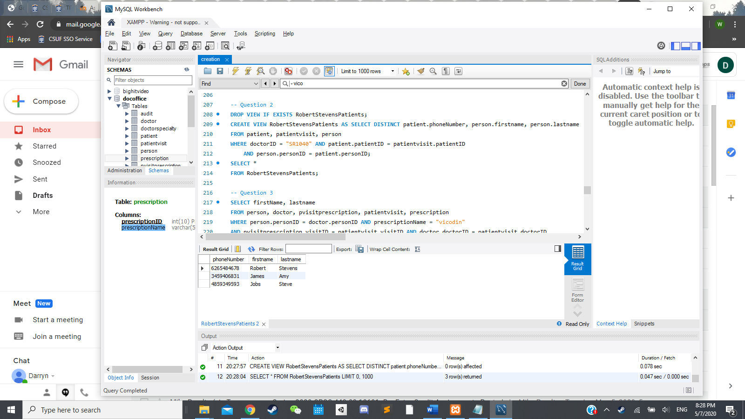

## 3. Create a view which has First Names, Last Names of all doctors who gave out prescriptions for Vicodin.

All the code is located in creation.sql file under the comment “question 3”  
Here is a screenshot of the result how it looks like

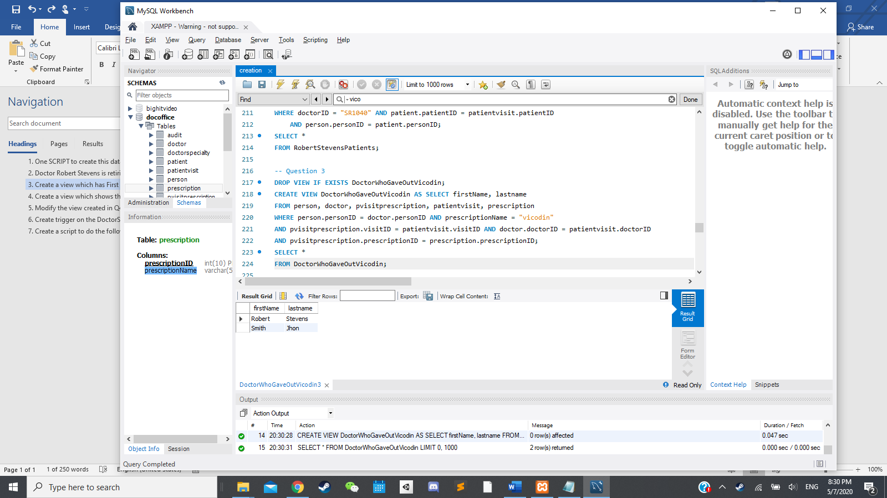

## 4. Create a view which shows the First Name and Last name of all doctors and their specialty’s.

All the code is located in creation.sql file under the comment “question 4”  
Here is a screenshot of the result how it looks like

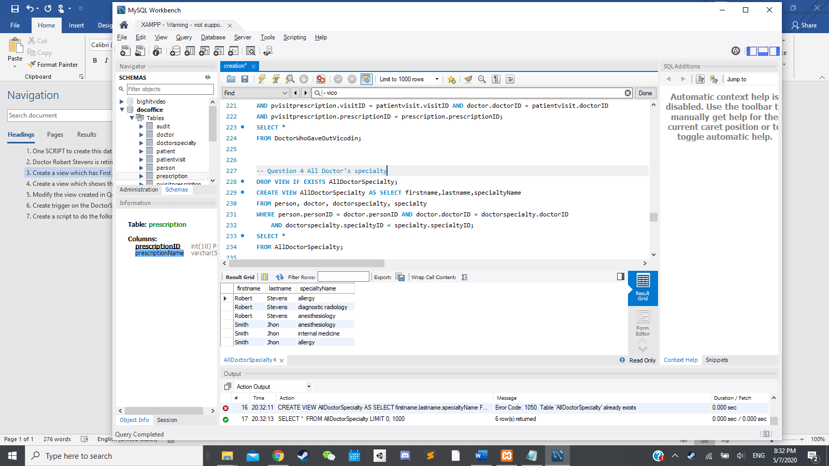

## 5. Modify the view created in Q4 to show the First Name and Last name of all doctors and their specialties ALSO include doctors who DO NOT have any specialty.

All the code is located in creation.sql file under the comment “question 5”  
Here is a screenshot of the result how it looks like

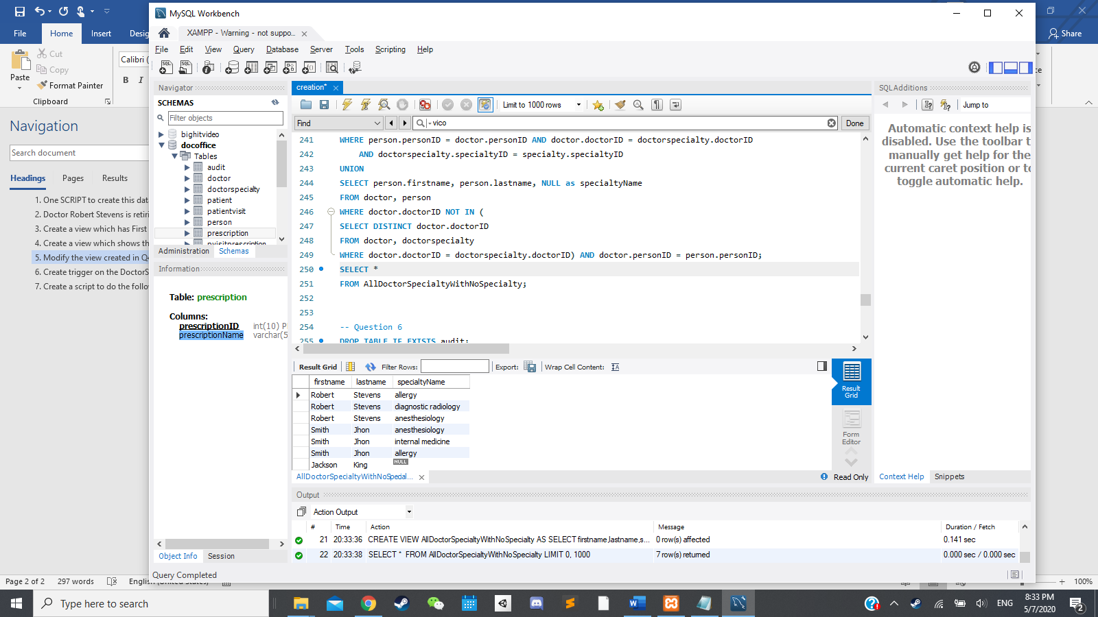

## 6. Create trigger on the DoctorSpeciality so that every time a doctor specialty is updated or added, a new entry is made in the audit table. The audit table will have the following (Hint-The trigger will be on DoctorSpecialty table). a. Doctor’s FirstName b. Action(indicate update or added) c. Specialty d. Date of modification

All the code is located in creation.sql file under the comment “question 6”

## 7. Create a script to do the following (Write the script for this) a. If first time backup take backup of all the tables b. If not the first time remove the previous backup tables and take new backups.

The script is located in the “Database and Queries” folder called “mysqldump.sh”